LCP Battery Shutdown Guide

Disconnect Battery Power
- Open the power and comms port by removing the stainless steel plug fitting. Be careful and make sure to put a wrench on both the stainless steel plug and the PVC fitting to avoid twisting up the wires.
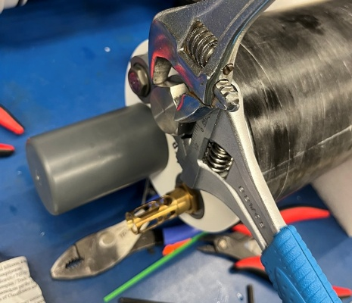
- Using needle nose fliers, on the 3-D printed part’s tab, pull the coms and power cartridge out of the port fitting. It will pull out only a few inches, see pic. DO NOT pull it out further than shown as this will put strain on the wires.
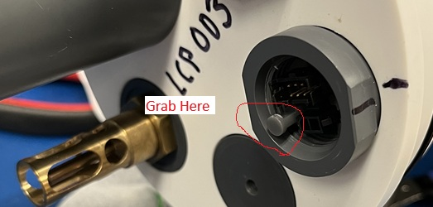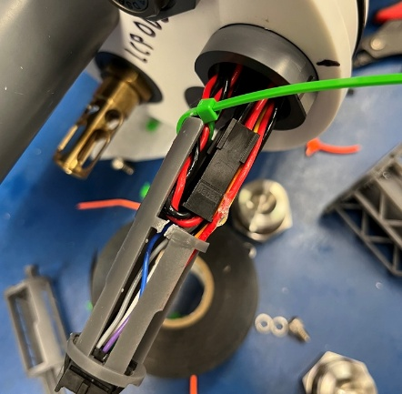

- DO NOT snip the green ziptie, Disconnect the 8-pin battery power connector:
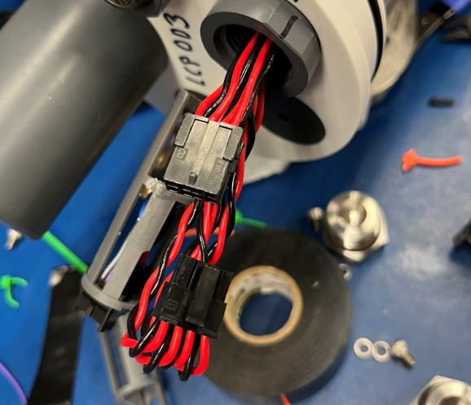
- Tape the free end of the connector just below the end of the grey comms and power cartridge, to the wires leading into the case (to keep it from falling into the case).
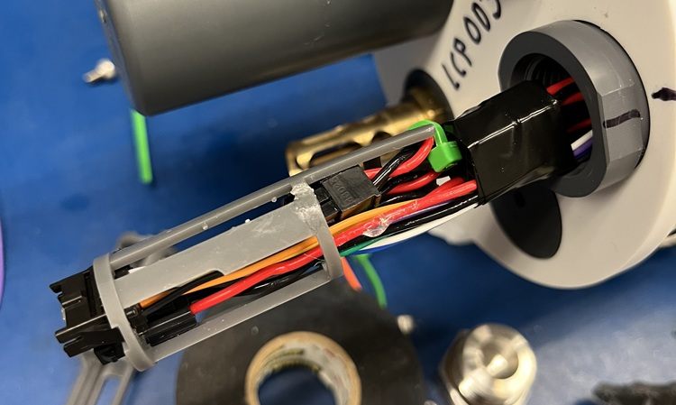

- Massage the wiring to lie as flat as possible and insert the entire cartridge assembly back into the port. You may have to wiggle it and massage it a bit to get it to fully insert.
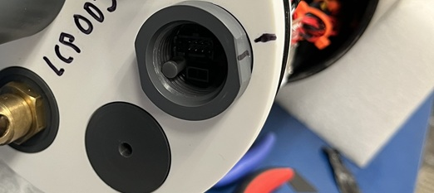
- Re-install the stainless steel port plug, being careful to use two wrenches to avoid twisting the wires.

- The LCP is now fully shutdown, watertight, and ready to be shipped back to PMEL, it has NO HAZMAT, just alkaline batteries.

